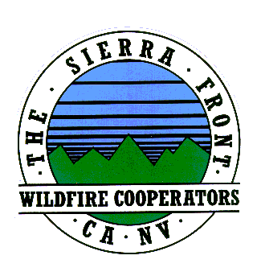
Announcement
Nate Rasner Sierra Front Type 3 Team
Mark Regan
Public Information Officer
Phone: 760-647-6472
Walkerfire2015@gmail.com
August 18, 2015, Announcement #2, 12:30 p.m.

Date Started: 8/14/2015  Cause: Human | Total Personnel: 471  Injuries/Illnesses to Date:0
Size: 3,613 acres | Structures Threatened: 235
Percent Contained: 20%  Resources: 5 helicopters, 0 seats 2 Air tankers Engines29,Crews8,Water Tenders 1, Dozers4 | Structures Lost: 0  Estimated Containment:8/23/2015

Campground Escorts in effect until 3:00pm today

Lee Vining, CA:For the campers that were evacuated along Hwy 120 (Tioga Pass), there are escorts today into those campgrounds for property and belongings to be retrieved. The escorts will take place until 3:00pm this afternoon and tomorrow, Wednesday, August 19th 9 a.m. – 3 p.m. depending on law enforcement availability.
If you need to get into a campground, there is an escort station set up at Hwy 120 just past the Tioga Mobile Mart. You will see 3 cones in the roadway near the bus stop. Please pull over at these cones and wait for the proper law enforcement escort into your campground.
The campgrounds in Lower Lee Vining Canyon remain closed, including Lower Lee Vining, Moraine, Boulder, Aspen Grove, and Big Bend Campgrounds.
The Upper Lee Vining Campgrounds are re-opening. These include Tioga Lake, Ellery Lake, Junction, Sawmill, and Saddlebag Campgrounds. Tioga Pass Resort and the Saddlebag Lake Resorts are open and the evacuation advisory is lifted.

###

