Properties
Attached are pictures of our two properties starting from the south end of 71053 Hwy 395 (red house) and ending on the north side of 71095 Hwy 395 (beige house). We purchased 71053 in September 2013 and 71095 in December 2014. Our intent is to physically enclose the two properties together with a continuous fence spanning both properties along Hwy 395. Combined the two properties have 320 feet of frontage along Hwy 395. Both properties are zoned ER.
Approvals Requested of Mono County
The current front fence limit of 4 feet is impractical given the positioning of the property line off the Caltrans 50 foot setback from the Hwy 395 center divider, exposing both properties to security threats and noise and lights from vehicle traffic along Hwy 395. Our need is for a 6 foot fence across the front yard of both properties, retained by stone pillars that could run a height of 7 or 8 feet.
Secondarily we’re looking to add a garage of up to 40 feet x 40 feet centered between the two properties. There is approximately 77 feet between the two properties and this is not possible with the current 30 foot side property setback requirements. If we are unable to get a variance, then we’re open to legally combining the two parcels to eliminate the side setbacks.
Existing Fence Coverage
71053 has an aging 3-1/2 foot high white picket fence that parallels Hwy 395, 50 feet off the center divider. This fence has to be torn down because it has rotted out and the root systems of the existing trees have broken it up. At the north end of the house the picket fence comes 24 feet back to the house, and then a 6 foot high wood and block fence, which is falling over from the root structures of previous trees, extends north to the property line. The white picket fence sits down approximately 4 feet below the surface of Hwy 395, so as you can see in the pictures, a 4 foot high fence in front provides no headlight or noise barrier from the Hwy. As it stands today, the living room and primary bedrooms in the house are adversely impacted by traffic 24x7, especially given that the house is only 24 feet back from the property line. The 6 foot high wood and block fence is not only ugly but, when moved forward 24 feet to continue along the property line, will drop in elevation and provide substantially less protection and privacy.
71095 is completely unprotected by any fencing. It sits even closer at about 20 feet from the property line along Hwy 395, impacted worse by the noise and lights from Hwy 395. The previous owners complained about safety concerns from individuals released from the Bridgeport jail that have hitchhiked south and shown up at the front door looking for assistance. During fishing season, even though signs are posted, fisherman frequently park on the highway and trespass across the property given its accessibility to Virginia Creek. These two properties sit along Virginia Creek in the only section of the Canyon where a full 50 foot Caltrans setback exists to the property, creating an open invitation for visitors to park and trespass across our properties, an almost daily occurrence throughout the tourist season.

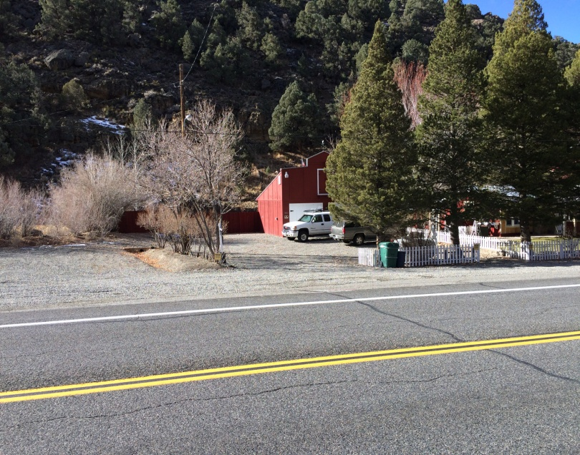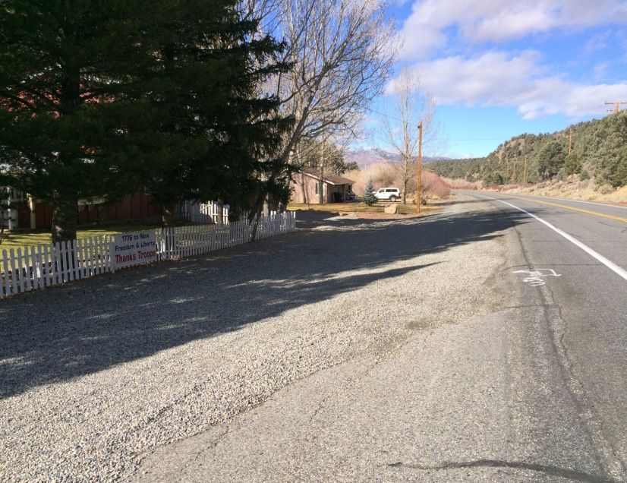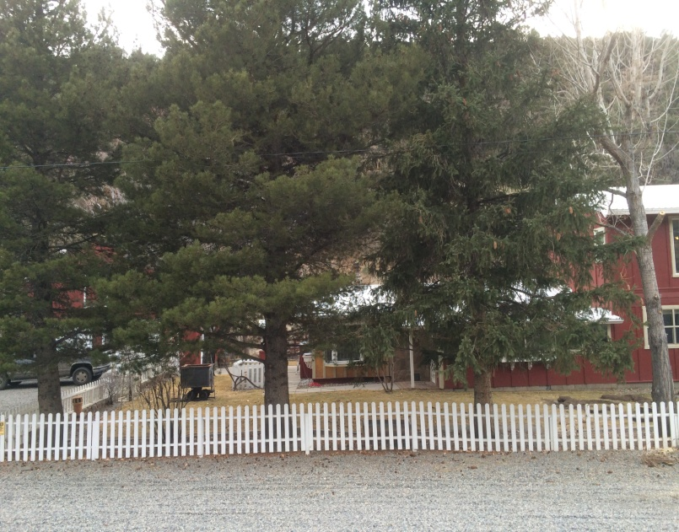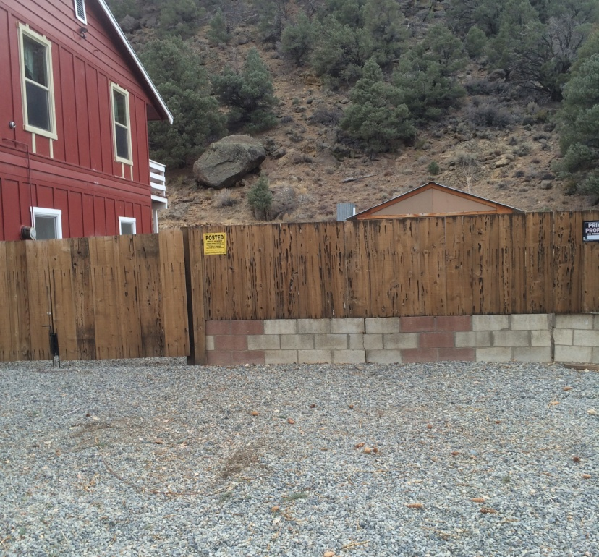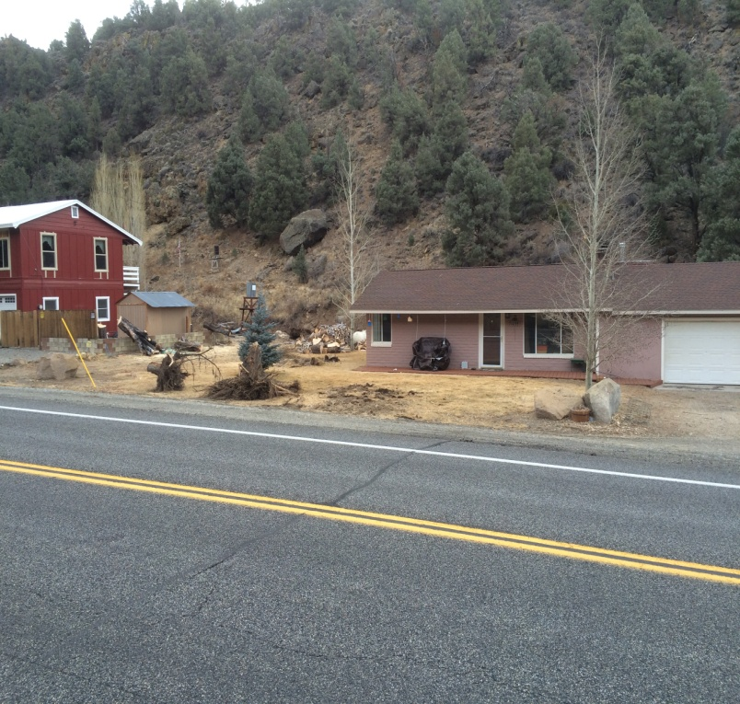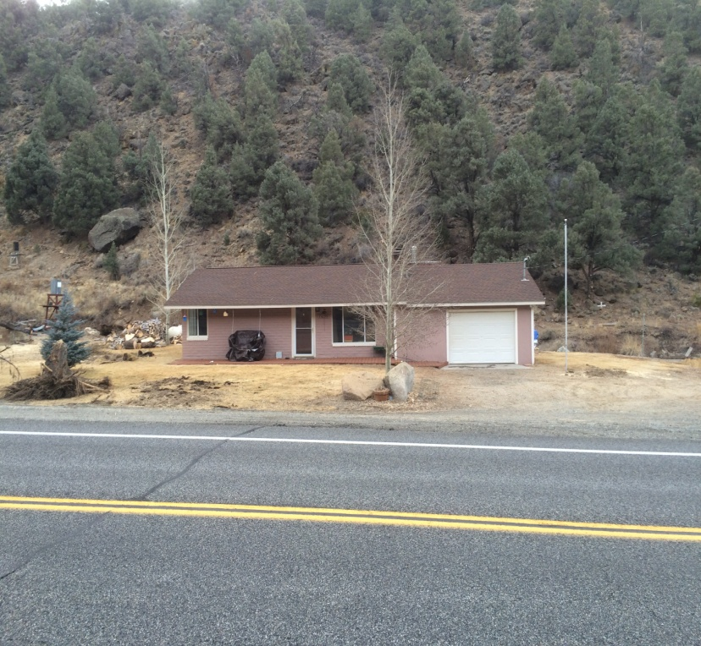
Requested for New Fence
We are looking to build a new fence parallel to Hwy 395 along the Caltrans 50 foot setback of the Hwy 395 center divider, starting at the north property mark of 71095 and running south to the end of the existing picket fence on 71053. The fence would be constructed as follows:
- 6 foot high redwood fence similar to this (but pillars made of local rock not brick). Pillars would vary in length:
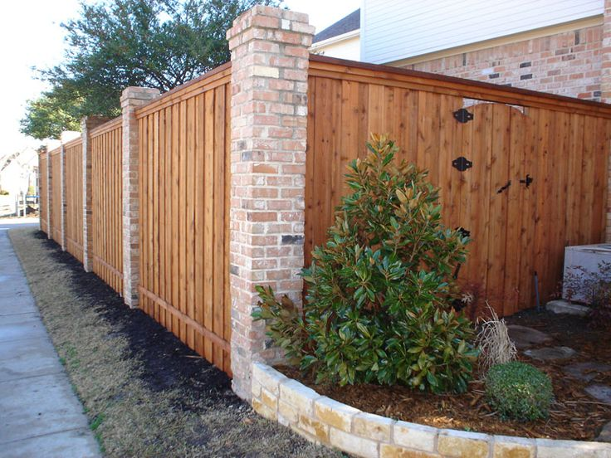

- Two approximately 12 foot wide redwood gates similar to this would be incorporated into the fence providing vehicle access to both parcels:
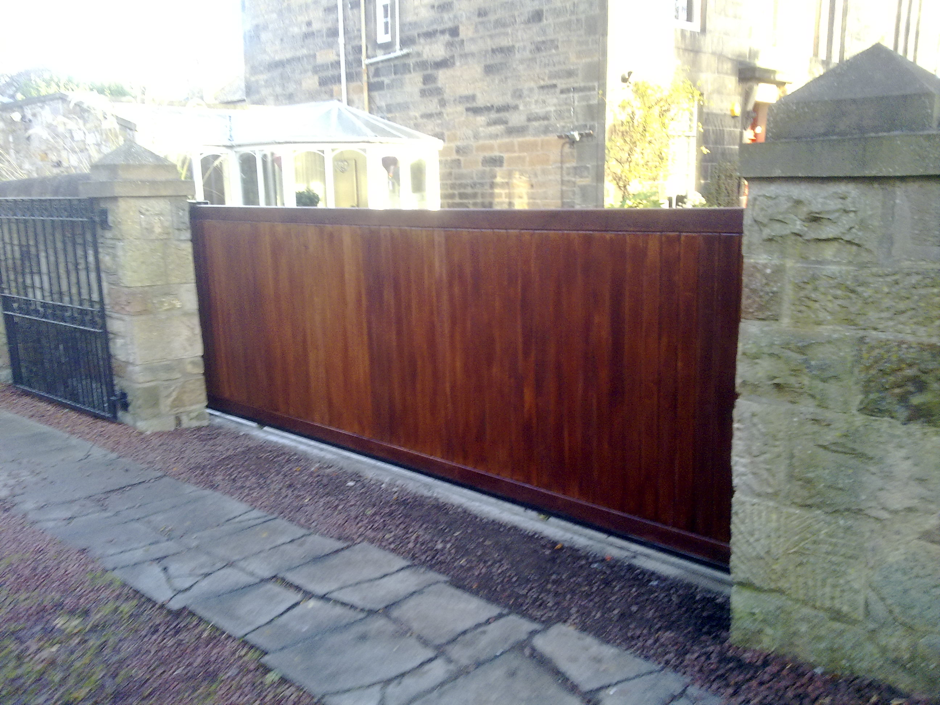

Owner Contact:
Debra Casados
PO Box 93
Bridgeport, CA 93517
Cell: 818-402-9780
Home: 775-760-932-1921
Email: Debbie.Casados@nexusis.com

Owners Authorized Representative:
Jon Jensen
Cell: 661-373-5976
Email: TahoeJon@frontier.com

