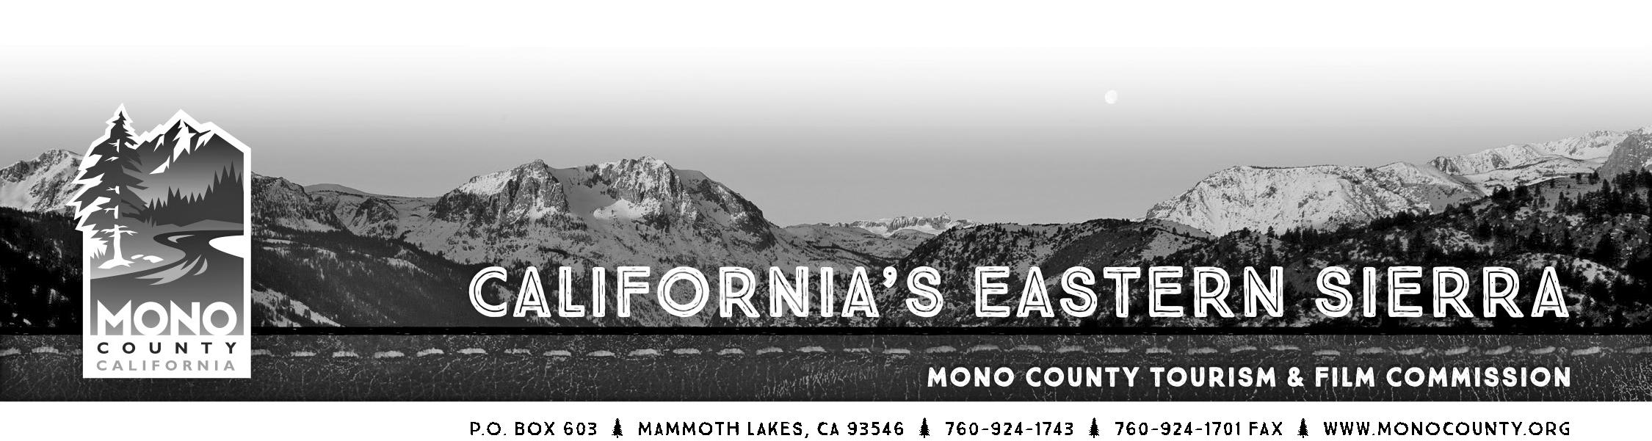

Mono County Tourism/Film Commission

Post Office Box 603
Mammoth Lakes CA 93546
760.924.1743 / 760.924.1697 (fax)

AGENDA

MEETING of Tuesday, June 23, 2015 - 10:00am
Board of Supervisors Room, Sierra Center Mall
452 Old Mammoth Road, Mammoth Lakes, CA 93546
- Call to Order.
- Introductions and announcements.
- Opportunity for the Public to Address the Commission on items of interest of the public which are within the subject matter jurisdiction of the Commission. (Speakers may be limited in speaking time depending upon the press of business and number of persons wishing to address the Commission.)
- Approval of the Minutes of April 3, 2015 special meeting.
- Approval of the Minutes of the May 26, 2015 meeting.
- Community Event Marketing Fund – Update and recap.

- Community Event Marketing Fund: Mammoth Lakes Wedding & Event Expo Report – Craig Schmidt, Mammoth Lakes Chamber of Commerce

- Business Retention & Expansion Survey/Peak Performance Program – Craig Schmidt, Mammoth Lakes Chamber of Commerce

- Public Relations Annual Report – Katie Shaffer, East River PR

- Monthly Financial/Budget Report.
- Commissioner Reports.

- Water supplies and irrigation on City of Los Angeles-owned lands in South County – Jennifer Roeser/Wendy Sugimura
ACTION: Discuss and determine if formal response from Commission and recommendation to the Board of Supervisors are desired.
- Economic Development Report.
- Tourism and Economic Development Agenda Items for Board meetings – discuss and schedule.
- Strategic planning: Discussion for both Tourism and Economic Development strategic planning for upcoming fiscal year.

- Mono County Tourism and Film Commission Ordinance and Bylaws Review.
ACTION: Review and approve the draft amendments to the MCTFC Ordinance and Bylaws.

- Fisheries Commission Report.
- Film Commission Update.
- New website development by Simpleview.
ACTION: Discuss and Approve DTN advertising opportunities with Simpleview on the new website.
- Project Status Update:
a. Collateral
b. Public Relations
c. Advertising/Social Media/E-Newsletter
d. Website

15. Call for Agenda items for next regular meeting.
16. Adjourn the meeting and reconvene in regular session on July 28, 2015, 10:00am at the Walker Community Center located at 442 Mule Deer Road, Walker, CA 96107.

