Larry Johnston-District One Fred Stump-District Two Tim Alpers-District Three
Tim Fesko- District Four Stacy Corless- District Five
Board of supervisors County of Mono
P.O. BOX 715, BRIDGEPORT, CALIFORNIA 93517
(760) 932-5538 ----- FAX (760) 932-5531
Bob Musil, Clerk of the Board
Mono County Behavioral Health Advisory Board
Meeting Agenda
December 12, 2016 --- 3:00pm-4:30pm
Behavioral Health Department Conference Room
Third Floor, Sierra Center Mall
452 Old mammoth RD
Mammoth Lakes, CA

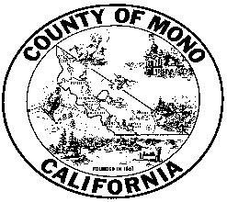

- Call to Order
- Public Comment
- Approval of Minutes from 8/8/16 and 10/17/16
- Davison House Discussion and Community Outreach planning
- Staff Reports
- Future Agenda Items
- Adjourn to next Meeting: To Be Announced

In compliance with the Americans with Disabilities Act, anyone who needs special assistance to attend this
Meeting can contact the Behavioral Health Department at 760-924-1740 within 48 hours prior to the meeting in order to ensure accessibility (see 42 USCS 12132, 28CFR 35.130).

